Membership Form
HACC: Halesowen Tennis Club
https://www.halesowentennisclub.com
Information for applicants:
- Subscriptions are from 1st April to 31st March inclusive.
- Membership Fees are listed on the next page.
- Junior ages are operative as of 1st April.
- Senior Citizen category applies if you will reach state pension age during the membership year. You can find out your state pension age at https://www.gov.uk/state-pension-age
- Full adult and student membership entitles you to all year-round tennis up until 10.00pm. There are no additional fees for using the lights; this is included in your membership.
- Off-peak membership allows you to play 9am – 5pm weekdays only with no lights.
- Parent membership allows you to play with your child when a court is free.
- Times when courts are allocated to priority sessions and not normally available for general use are published on the court schedule (on website and in clubhouse).
- Please tell the membership secretary If you have already paid a subscription to the HACC Main Club via another section. The main club fee will then not be included in your Tennis Section fee.
- Cases of hardship may be eligible for a reduction in fee or eligible for a payment plan. A letter should be presented to the Committee for consideration.
- All persons signing this form agree to conform to the Rules & Conduct Code of the Club, as described in the Membership Handbook (a printed copy is displayed in the clubhouse, and a copy is available on the club website). This agreement is the responsibility of a Junior’s parent(s)/guardian(s) who must complete and sign on behalf of the Junior member(s)/applicant(s).
- Membership Secretary is: Jim Randle; halesowentc@gmail.com

British Tennis Membership - The Lawn Tennis Association: www.lta.org.uk
As a Tennis Club Member, you are automatically eligible for British Tennis Membership. Please ensure you take this up via the LTA website. This is required to access the club booking tool in ClubSpark. Instructions on how to sign up to the LTA and ClubSpark are provided as part of your membership confirmation.

Data Protection / GDPR Policy:
The personal information we hold about you is held securely in ClubSpark and can only be accessed by authorised officers of the club. For full details, please see our GDPR Policy on the club website, on the Home page.

We occasionally post Club photographs on our HTC website, or in local newspapers or our own newsletter. If you do NOT want your image or that of your child(ren) to appear, please inform the club.

Juniors Information:
In addition to the membership, monthly coaching fees for the juniors are payable to participate in the coaching program:
- £25.00 per month per child
- Payable by Standing Order only, to be scheduled for payment on the 1st of each month
- Bank details for S/O are as shown on the application page
- Entitles your child to attend 1 coaching session per week
- Sessions are organised by age and standard
- For more information, details can be found under the Coaching section of the website where the Head Coach’s details are also listed
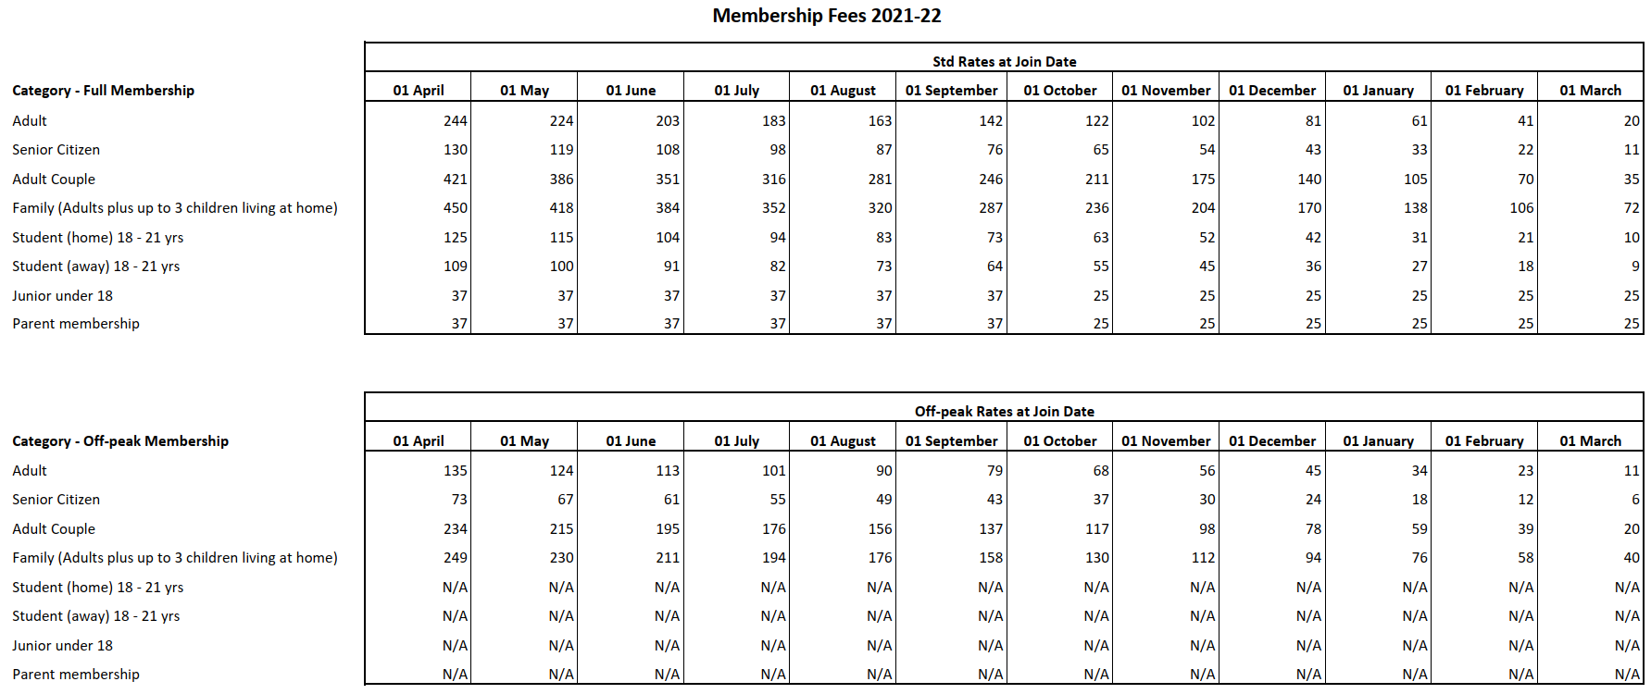
Membership Application
Full name and date of birth and contact number of each member applying on this form:

Name of applicant | Date of Birth | Contact number
1
2
3
4
5

Details of person completing this application:

Mr/Mrs/Ms/Miss…………………………………………………………………………………………………………
Address………………………………………………………………………………………………………………......

.......................................................................................................................…. Postcode.……………………

Tel No………………….……… Mobile………....................…………… Email …….……………………………
Complete application details below:
Membership Category | Is this an  off-peak application? | Number in each category | Total cost in each category | Additional information
Adult
Senior Citizen
Adult Couple
Family | P.O.A. (Contact Membership Secretary)
Student (away) 18-21 yrs | N/A
Student (local) 18-21 yrs | N/A
Junior Under 17 yrs | N/A
Parent membership | N/A
TOTAL fees due £

Please indicate your method of payment in the table below. Write/type “Yes” in selected field. Please note, our preferred method is by online BACS transfer.

Payment Method | Details | Selected
BACS Transfer | Sort Code: 20-27-17 Account: 70552100. Account name: HACC tennis. Use your family name as reference
Cheque | Made out to ‘HACC tennis’

Please email completed form to halesowentc@gmail.com. Alternatively, post (with cheque if relevant) to membership secretary: Jim Randle, 41 High Haden Road, Cradley Heath, West Mids, B64 7PG. On receipt of your renewal form and payment, you will receive confirmation of your membership and membership number, usually by email.

Signature | Name (please print) | Date

